FEBRUARY 19, 2015
we are stardust ...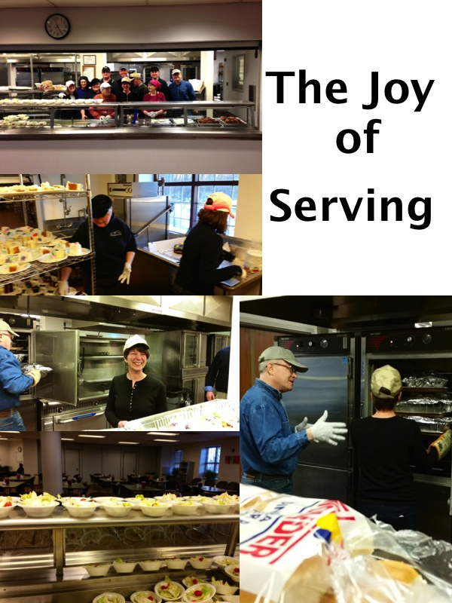

Last week, I wrote about how participating in acts of mercy can lead to a craving for Social Justice. So, to put my words into action, my husband and I joined a team from Family Promise and served the Walk-In Dinner Program at the Housing, Health and Human Services Center, 120 South River Street, Hackensack. It was Shrove Tuesday, otherwise known as Mardi Gras, and it was a wonderful moment of grace for us. We served fried chicken, a variety of salads, rolls, cake, iced tea and coffee to over 100 people - each seeking a hot meal on a cold night.
Family Promise has been committed to feeding the hungry since 1991. Every day of the year, a different group is scheduled to prepare and serve dinner at the Health and Human Services Center in Hackensack. Up to 150 people are served a nutritious meal each night. Many of the guests utilizing the program are residents of the shelter. However, the program is open to anyone in the community, no questions asked.
People came from all walks of life, in all manners of dress from business-interview attire to casual jeans. There were families, singles, and couples. All were gracious and I could not help but be filled with joy because I was lucky enough to be serving macaroni salad in abundance! (I have a hard time saying "no", so I could not work the cake station because we only had one slice of cake per person.) Our two hours of service flew by, and Mike and I left the center filled with more joy than any Mardi Gras cocktail could bring.
I strongly urge you to consider volunteering to serve at the Walk-In Dinner Program, and witnessing this moment of neighbors loving neighbors yourself. You can learn more about this program and how to volunteer by contacting Family Promise Volunteer Director, Margo Heller, at 201 833-8009 or visiting bergenfamilypromise.org
The day after our service was Ash Wednesday, and in contemplating the traditional Ash Wednesday rituals in light of my experience the night before, I was moved to write the following on my personal Facebook page:
"remember you are dust, and to dust you shall return" - these powerful words, spoken on Ash Wednesday, remind me that we are all carbon - we are all made of stardust - we are all God's children - and we are all one together created from the One. The older I get, the more I study, the more profound these simple truths become for me. May you find blessings in the coming weeks, whatever holiday or seasons you celebrate.

In Christ's Peace, Lisa

